Article Template for UHVNet 2024

Author list in format: A N Author*1, B N Author1 and C N Author2

1First Affiliation, address

2Second Affiliation, address

*E-mail: Contact author’s email address here

*Abstract--* (max 250 words) This document gives formatting instructions for authors preparing an article in Microsoft Word for publication in the programme for UHVNet2024. The authors are asked to follow the instructions given in the document when preparing their article to assist with the preparation of the programme. You can use this document as both an instruction set and as a template into which you can type or paste your own text. When submitting your paper, please write your paper information in the email subject in the form of ‘UHVNet 2024 Abstract_Name of the first author_Paper title’.

Please email your abstract to [info@uhvnet.org.uk](mailto:info@uhvnet.org.uk)

Background & Main Results

Establish the context and rationale for the work.. Up to 3 references may be included using the numeric format provided.

If including a figure, the maximum dimensions height = 6.5 cm and width = 9 cm. A caption should be included underneath the Figure, as shown.

The complete abstract should fit onto a single side of A4 paper with margins set as follows: Top/Bottom: 18mm, Left/Right 16.5mm.

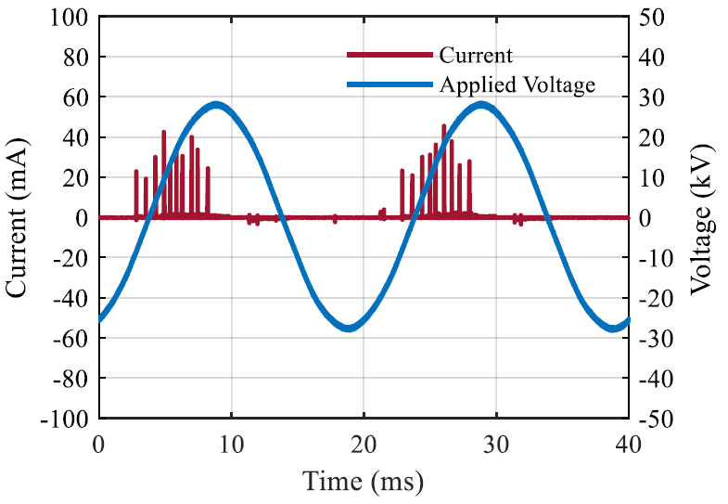

Figure 1: This is an example Figure with its dimensions set to the maximum recommended size.

Conclusions

Birefly state the key conclusions/findings/contributions of your work

References

1. D. Pinzan et al., "Performance of Composite Outdoor Insulator Under Superimposed Direct and Switching Impulse Voltages," IEEE Transactions on Power Delivery, Vol. 36, Issue 2, pp. 1193-1201, April 2021.
2. H. Abdul Hamid, N. Harid, M. A. Haddad and H. Griffiths, "Modelling of a 400-kV MSCDN Reactor for Computation of Voltage and Field Distributions During Switching Transients," IEEE Access, Vol. 6, pp. 36247-36255, June 2018.
3. M. Michelarakis, G. Gulics, E. Bailey, S. Lane, R. Montano and A. M. Haddad, "Retrofit of Outdoor Medium Voltage Circuit Breaker with Eco-Friendly Gas to Replace SF6," CIRED 2021 - The 26th International Conference and Exhibition on Electricity Distribution, September 2021.